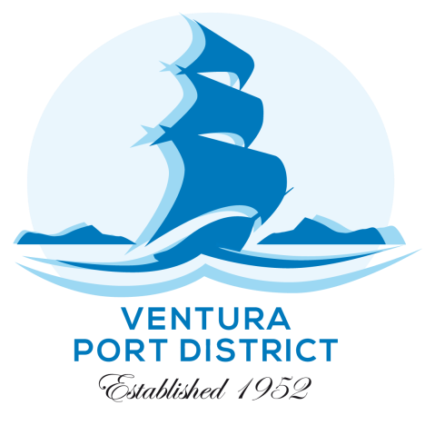

April 2024

The Ventura Port District, and equal opportunity employer, is advertising to hire Part-Time On-Call Marine Safety Officers to join our team. This position is an entry-level public safety position and works under the direct supervision of the Harbor Patrol Department and provides support in performing their daily duties. The duties include shift work, working in adverse conditions, responding to emergencies on land and sea, performing first aid, boat maintenance, and performing swim rescues in dangerous ocean conditions.

Minimum qualifications: 18 years of age, California Class C Drivers License, two years of Ocean Lifeguard Experience, valid California EMT, current CPR card, ability to pass 500 meter swim annually.

If you are interested in this position, please return the attached application by email to jrauch@venturaharbor.com or by mail to Ventura Port District, 1603 Anchors Way Drive, Ventura, CA 93001. Applications will be accepted until positions are filled. You may submit a resume and a few supporting documents with the application.

APPLICATION DEADLINE: Tuesday May 17th by 5:00 pm

Process: Top applicants will be invited to participate in a pass/fail swim test of 500 meters in 10 minutes or less, and oral interviews as part of the pre-employment selection process. Interviews will be scheduled the following week.Upon job offer, new hires will be required to pass a drug test, physical exam, and a criminal history check.

Swim Test Dates: May 25th & 26th.
Location: Ventura Harbor Patrol Office (1603 Anchors Way Drive Ventura, CA 93001)
Interviews: TBD

Additional Info: A job description for this position is attached, as well. The starting salary for entry-level Marine Safety Officer is $19.49 per hour. The salary range for this position is $19.49 - $26.52.

I wish you success in the process and look forward to receiving your information
Sincerely,

Brian D. Pendleton
General Manager

